User Control and Freedom

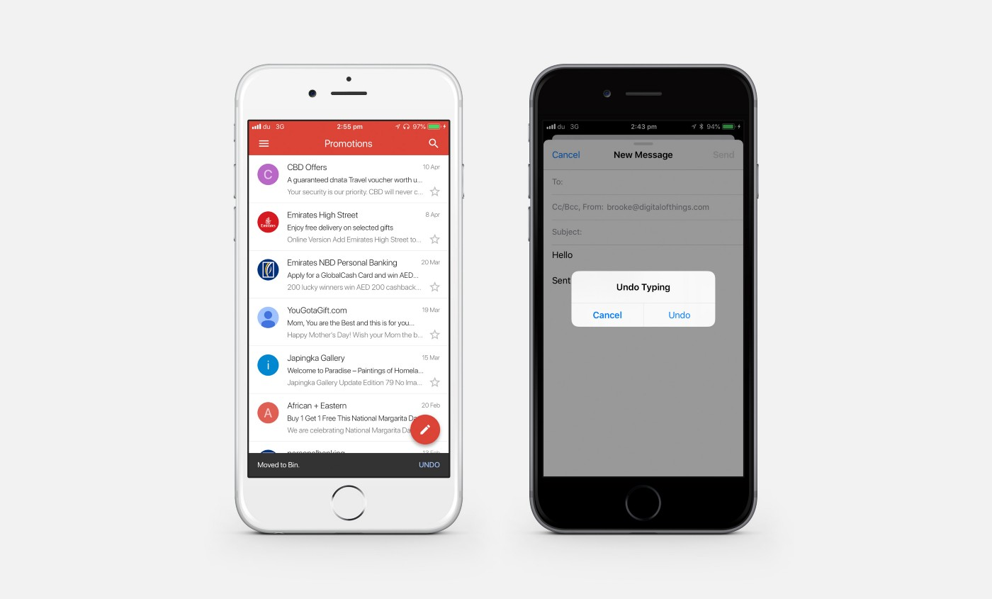

Users can undo their deleted messages.

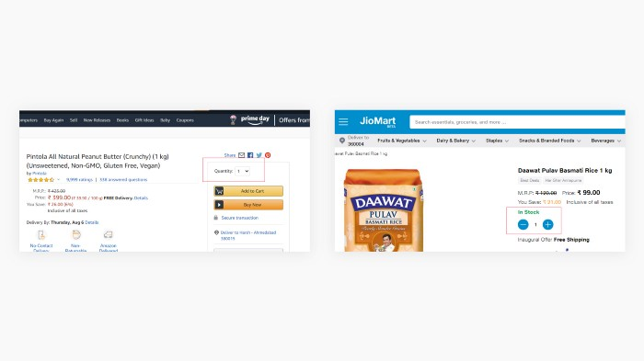

Customers has the feature to increase or decrease the quantity of their orders.

**Principle Example**

1. Define principle
2. Match or not
3. Reason and Suggestion

Purpose User Support

Assumption

Conceptual Model (online sale system)

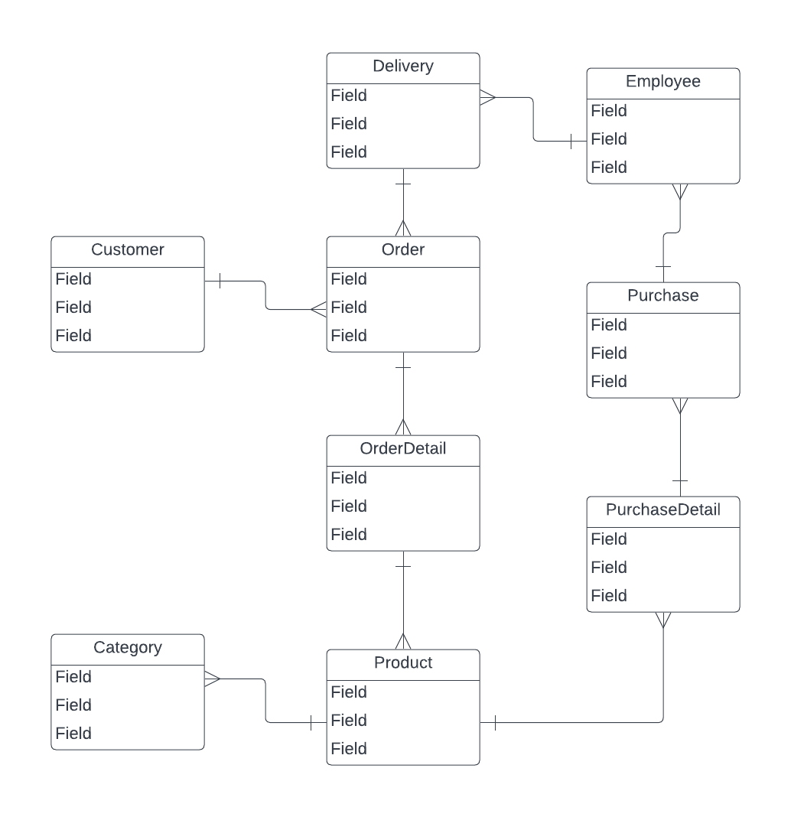

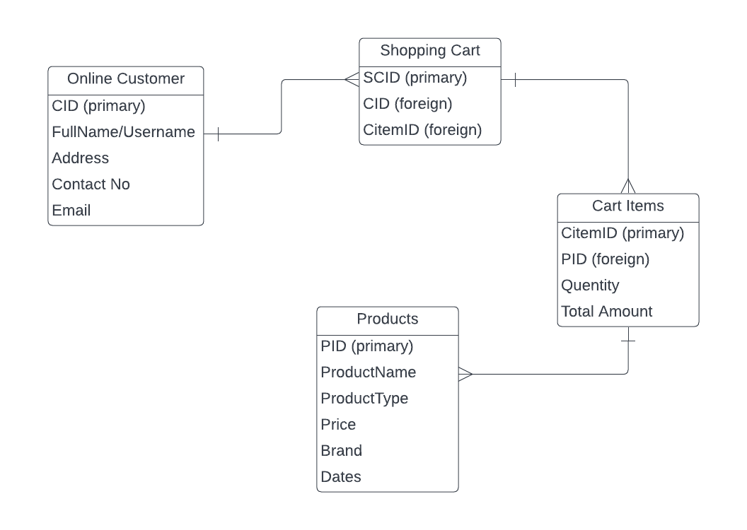

**5 Dimensions of Interaction**

**Design Principle**

1. User: Customer, Segmentation, Parents, Company, Owners, Car Owners, Etc.
2. Insurance Type
3. Fact finding: interview, observation, etc.
4. Questions

Online Insurance System- Conceptual Model (at most 10 people, a least 5 questions.) (H.W)